**EXERCISE 2**

1. Install the **tree**command which is necessary.
2. Using shell commands create the following directory structure.

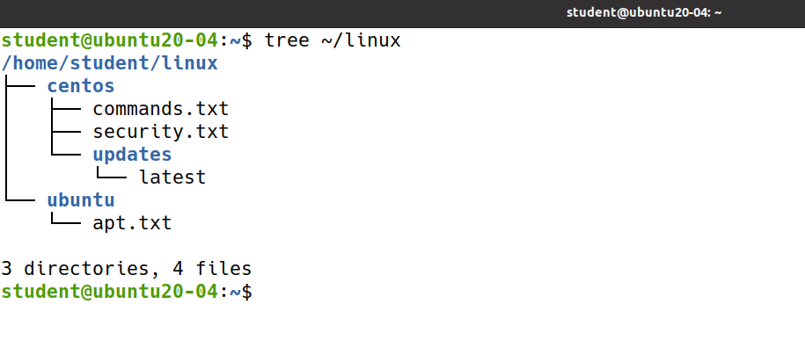

1. Considering this directory structure, copy the file called **security.txt** to the **updates**directory.
2. remove the file called **security.txt** from the directory called **updates**.
3. Considering the initial directory structure, copy the directory called **updates**from **centos**to **ubuntu**.
4. remove the directory called **updates**from the **ubuntu**directory.
5. Considering the initial directory structure and using only one command copy the file called **apt.txt** and the directory called **updates**to **linux**directory.
6. remove the file called **apt.txt** and the directory called **updates**from the **linux**directory interactively (by prompting the user).
7. Considering the initial directory structure, rename the directory called **centos**to **redhat**and then back to **centos**.
8. Considering the initial directory structure, copy the file called **security.txt** to **ubuntu**directory as **sec.txt**
9. Create a file named **users.txt** by redirecting the output of the who command.
10. Display the file contents.
11. Remove the file in a secure manner by overwriting the file 50 times before removing it.
12. Remove the entire directory structure without prompting.